Range Display HMI for PHEV – CGEA1.3

Functional Description

The Range Display HMI for PHEV will display both the DTE for the Gas fuel and the DTE for the Battery. The actual display may depend on the vehicle deplete, sustain or locked sustain modes.

The system shall determine the hybrid /electric mode of the car and accordingly display the gasoline and electric range. The hybrid mode can be determined from the HybMdeStat_D_Dsply CAN signal for both FORD and Lincoln vehicles. With this update both Ford and Lincoln will use same signal ‘HybMdeStat_D_Dsply’ to reduce complexity.

The Range Display HMI for PHEV correlates the DTE_MC_value, VehElRnge_L_Dsply, and HybMdeStat_D_Dsply to determine the Range Display to be shown.

Graphics are unique for China variants , thus we use China BEV/xHEV configuration.

Interfaces

Interface Context Diagram (I/O Block Diagram)

Range Display for PHEV Context Diagram

Inputs

IR-REQ-325831/A-Internal:

- Operational_Mode
- DTE_MC_value (Parameter is defined as an output in “Distance to Empty Function - IPC or PCM Algorithm - CGEA1.3_vx.x.doc”)
- Display_Units_MC

MUX signals

SIG-REQ-325821/A-HybMdeStat_D_Dsply Signal

Signal Name | Size (bits) | Detail | Units | Res. | Offset | State Encoded | Min | Max
HybMdeStat_D_Dsply | 3 |  | SED | 1 | 0 |  | 0  (0x0) | 7  (0x7)
 |  | Null State |  |  |  | 0x0
 |  | Auto Charge Deplete Mode |  |  |  | 0x1
 |  | Auto Charge Sustain Mode |  |  |  | 0x2
 |  | Forced Charge Sustain Mode |  |  |  | 0x3
 |  | Forced EV Mode |  |  |  | 0x4
 |  | EV_Override |  |  |  | 0x5
 |  | Not Used |  |  |  | 0x6
 |  | Not Used |  |  |  | 0x7

SIG-REQ-325820/A-VehElRnge_L_Dsply Signal

Signal  Name | Size  (bits) | Detail | Units | Resolution | Offset | State  Encoded | Min. | Max.
VehElRnge_L_Dsply | 12 |  | km | 0.1 | 0 |  | 0  (0x0) | 4095  (0xFFF)
 |  | Unknown |  |  |  | 0xFFE
 |  | Faulted |  |  |  | 0xFFF

Outputs

IR-REQ-325830/A-Internal:

- Range_Display_PHEV
- DTE_display
- ElectricRange_display

Function/Performance

F-REQ-325837/A-Operational Modes

Mode | Differentiating Vehicle Conditions
Sleep Mode | Range Display HMI Off
Limited Mode | Range Display HMI Off
Normal Mode | Range Display HMI On/Off
Crank Mode | Range Display HMI On/Off

Voltage Levels

Refer to Cluster Features table located in Operational Modes and Voltage Range Strategies Section in this SPSS.

Human-Machine Interface

Visual

Indicator Graphics / Display Format

Ford Programs Sample Graphics
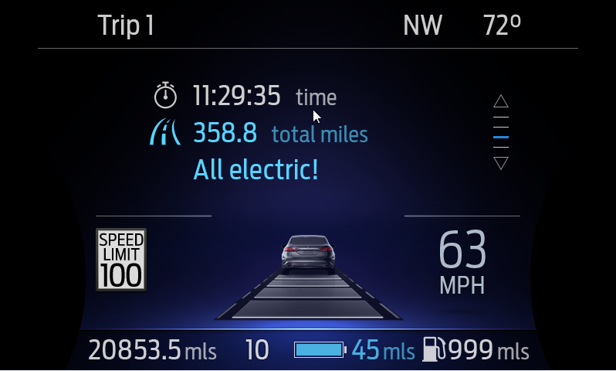
U625 S25 EV IOD Screen: Both Electric and Gas Range Displayed and Highlighted

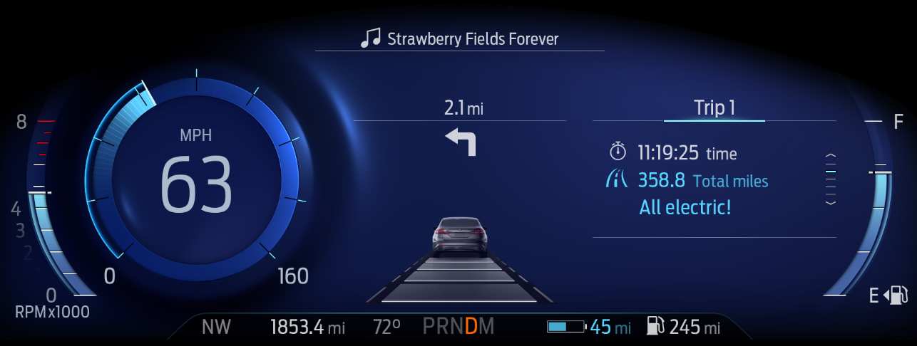
U625 SX IOD example screen : Both Gas and Electric Range displayed and highlighted

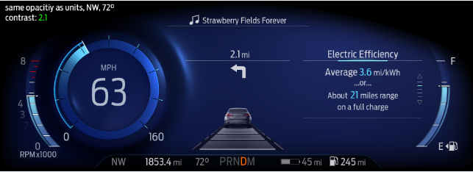
Electric Range and Battery Grayed Out
U625 SX IOD example screen : Both Gas and Electric Range displayed, Electric Grayed and Gas highlighted

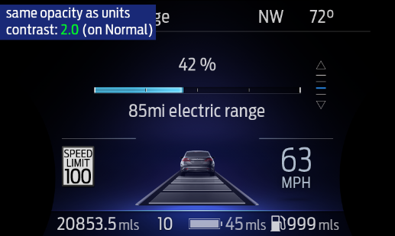
Electric Range and Battery Grayed Out
U625 S25 EV IOD Screen: Both Gas and Electric Range displayed, Electric Grayed and Gas highlighted

Note : Example of Gas Grayed out is not available in this STSS so please refer actual Gaphics from HMI and Studio.

Above are example graphics. Actual graphics are to be provided by Ford HMI or Studio and approved by the DI Application for each program.

Lincoln Programs Sample Graphics

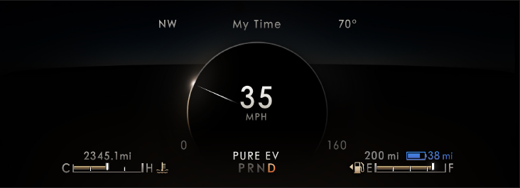
Gas Range
Grayed Out
U611_CX483: Both Gas and Electric Range displayed and Electric highlighted and Gas Grayed Out

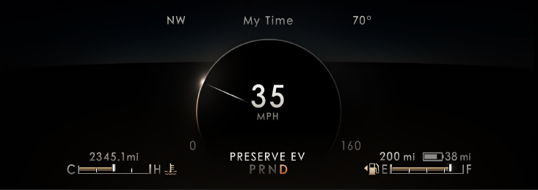
Electric Range and Battery Grayed Out
U611_CX483: Both Gas and Electric Range displayed and Gas highlighted, Electric Grayed Out

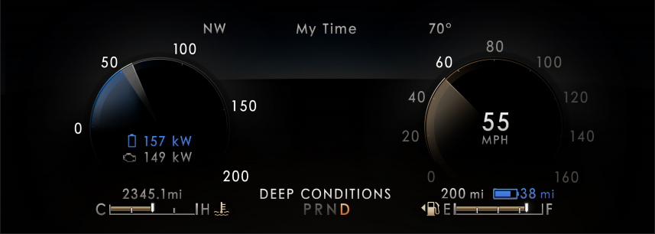
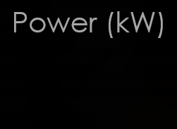

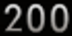
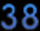
No Battery Symbol for China Market

U611_CX483 : CHINA ONLY Graphics Example

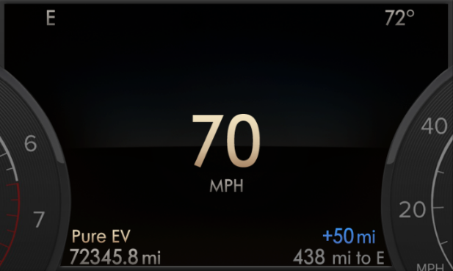
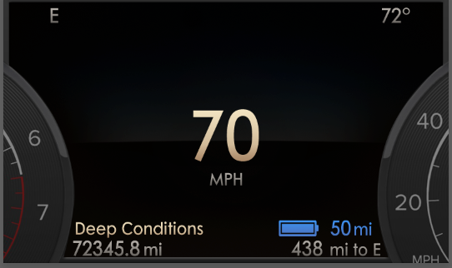
No Battery Symbol for China Market
Battery Symbol for Non-China Market

Non-China Market China Only

All these graphics provided are samples for better understanding. Actual graphics are to be provided by Ford HMI or Studio and approved by the DI Application for each program.

HMI-REQ-325840/A-Battery Icon Display Configuration for China

- When China BEV/xHEV configuration is enabled there shall not be any battery icon in Display.

Indicator Color Coordinates

Reference Ford HMI or Studio Wallpaper files for the specific program.

Indicator Characteristics

Reference Ford HMI or Studio Wallpaper files for the specific program.

Audio

None.

Switch Control Logic

N/A.

System Accuracy

PFM-REQ-325832/A-Display Response Time

- Within a 100msec of receiving a message/input that results in a change of state the cluster will update the display to the proper status.

F-REQ-325833/A-Km to Miles Conversion Unit

- Shall use kilometer to miles conversion constant of 1/1.609344.

Operation: Performance and Functional

Subsystem Algorithm Flowchart / State Diagram

F-REQ-325822/B-Flowchart for CAN Diagnostic Configuration Routine

F-REQ-325823/B-Electric and Gas DTE Display Matrix

Opertional Mode | PT_Hyb  _Cfg2 | HybMdeStat_D_Dsply | Highlighted Display  (Electric, Gas) | Dimmed/ Grayed out Display (Electric, Gas) | Range_Display_PHEV  (Internal Variable)
Normal/  Crank | PHEV (0x3) | 0x0 (Null State) | Gas and Electric | - | 0x0
Normal/  Crank | PHEV (0x3) | 0x1 (Auto Charge Deplete Mode) | Gas and Electric | - | 0x0
Normal/  Crank | PHEV (0x3) | 0x2 (Auto Charge Sustain Mode) | Gas | Electric | 0x1
Normal/  Crank | PHEV (0x3) | 0x3 (Forced Charge Sustain Mode) | Gas | Electric | 0x1
Normal/  Crank | PHEV (0x3) | 0x4 (Forced EV Mode) | Electric | Gas | 0x2
Normal/  Crank | PHEV (0x3) | 0x5 (EV_Override) | Gas and Electric | - | 0x0
Normal/  Crank | PHEV (0x3) | 0x6 (EV Charge) | Gas | Electric | 0x1
Normal/  Crank | PHEV (0x3) | Others | Retain the last Hybrid_Mode | Retain the last hybrid mode | Retain the last known value

F-REQ-325824/C-Range Display for PHEV Routine – All Programs

F-REQ-325825/C-Range Display for PHEV Routine – Lincoln Programs

Not Applicable.

F-REQ-325826/A-Electric Range Calculation

F-REQ-325827/B-ActvDrvMde_D2_Stat Signal
Not Applicable.

F-REQ-325838/B-Range_Display_PHEV – Lincoln Programs

Not Applicable.

Operation Description (supports algorithm flowchart /state diagram)

F-REQ-325828/A-VehElRnge_L_Dsply Signal Missing\Unknown

If VehElRnge_L_Dsply is missing or faulty or unknown, then Electric Range should show “- -“

F-REQ-325829/A-DTE Display

If the DTE for Gas fuel is being displayed as “- -“ as per DTE Function - CGEA STSS, then the DTE for Gas would be displayed as “- -“

FS-REQ-325839/A-Function Safety Classification (EMC)

Class B

NVM-REQ-325834/A-Memory Storage

Parameter Name | Description | Value at Battery connect | Value at  Module Wake-up
Display_Units_MC | Defined as an output in Unit Selection Control Function STSS.  Input to this routine that controls display indicating units to the driver (i.e. when English: miles, mpg; when Metric: km, L/100 km, km/L). Parameter is to be stored in Battery Backed RAM. | Used Stored Value (See Display Unit Selection Control Function STSS) | As per Display Unit Selection Control Function – CGEA1.3 STSS
VehElRnge_L_Dsply (CAN) Signal | CAN signal sent from the PCM for Remaining Distance | As per CAN Message List | Do Not Init
DTE_MC_value | Defined and calculated in DTE Function - CGEA STSS as a filtered output that is used to display distance to empty to the driver (Units = km).  Input to this routine for DTE for Gas fuel. | As per DTE Function – CGEA1.3 STSS | As per DTE Function – CGEA1.3 STSS
ElectricRange_Display | Output indicator for Electric Range display | 0x0 | 0x0
HybMdeStat_D_Dsply | CAN Input to indicate Hybrid Mode State to be displayed by IPC. | 0x0 | Do Not Init
DTE_display | Output for DTE for Gas fuel in current display units for the Range Display PHEV | 0 | Do Not Init
Range_Display_PHEV | Output to indicate the content of the Range Display PHEV  0x0 – DTE – GAS and DTE – Battery Range BOTH displayed and highlighted  0x1 – DTE – GAS and DTE – Battery Range BOTH displayed and GAS Highlighted  0x2 – DTE – GAS and DTE – Battery Range BOTH displayed and Electric Highlighted  0x3 – Missing/unknown/faulty VehElRnge_L_Dsply, Invalid DTE_MC_Value | 0x0 | 0x0
Operational_Mode | Input to this routine that is a 4 State indicator for cluster operational mode | As per Operational Modes and Voltage Range Strategies Section (STSS) | As per Operational Modes and Voltage Range Strategies Section (STSS)
PT_Hyb_Cfg2 | Configuration bit for HEV Configuration.  PT Hybrid2(PT_Hyb_Cfg2)  0x0 = Non-Hybrid  0x1 = BEV  0x2 = FHEV  0x3 = PHEV  0x4 = MHEV | Do Not Init | Do Not Init
China BEV/xHEV Cfg | China BEV/xHEV Function | Do Not Init | Do Not Init

Prove Out

No

Reconfigurable Telltale

No

Message Center Msg

Refer to Ford Studio Drawing

Error Handling

Missing Message Strategy

The signals will be declared missing as per the Diagnostics Section of this SPSS.

DTC states and history will be determined as per the Diagnostics Section of this SPSS.

Invalid Data Strategy

The signals will be declared invalid as per the Diagnostics Section of this SPSS.

DTC states and history will be determined as per the Diagnostics Section of this SPSS.

Diagnostics

Self Test

None

Engineering Test Mode

Reference section “Dealer / Engineering Test Mode (ETM)”.

Part II Performance

DTC-REQ-325835/A-Supported Diagnostic Trouble Codes (DTCs)

DTC | Description
C29300 | Lost Communication with Hybrid/EV Powertrain Control Module
C59400 | Invalid Data Received From Hybrid/EV Powertrain Control Module
C12100 | Lost communication with anti-lock brake system (ABS) control module
C41500 | Invalid data received from Anti-Lock Brake System (ABS)Control Module – No Update

DCR-REQ-325836/A-DID DExx

Block  Num | Block Description | Byte(s) | Bits | State: Description | "0" | "1" | Default | Comments/  Information
$09 | Option Content (B&A) |  | 3 | PT Hybrid2(PT_Hyb_Cfg2)  0x0 = Non-Hybrid  0x1 = BEV  0x2 = FHEV  0x3 = PHEV  0x4 = MHEV |  |  | 0x0 | Default from cluster plant to be 0x0 if cluster can be used on a Non-Hybrid.
$09 | Option Content (B&A) | * | * | China BEV/xHEV Function | Not China | China | Not China | For China (Peoples Republic of China) must be set to China for compliance to China reg GB/T 4094.2-2005. Taiwan MUST be set to Not China.

Reference Specification

IS-0344 GENERAL REQUIREMENTS (MSGCENTR)

- Manage EV Display_PHEV – CGEA1.3 STSS
- Appropriate Program Specific Text Translation File
- Appropriate Program Specific IPC Menu Structure File
- Appropriate Program Specific Wallpapers
- DIDC Requirements for 16MY Electric Range HMI PHEV Change Requests_v03.1_2014_07_16
- Operational Modes and Voltage Range Strategies – CGEA1.3
- Display Unit Selection Control Function – CGEA 1.3

Revision History

SPSS Module Revision History

Revision Level | Name | Change Description | Date
1.0 | T. Cwik | Initial Release based upon Ryan Skaff’s “DIDC Requirements for 16MY Electric Range HMI PHEV Change Requests_v03.1_2014_07_16 | 9/4/2014
1.1 | T. Cwik | Update to correct an error in initialization values.  Section 1.3.5.4 – Changed the values at Battery Connect and Module Wake-up for Range_Display_PHEV to 0x1. | 2/19/2015
1.2 | A. Venuturupalli  S. Watkins | Update to clarify Range_Display_PHEV values and content to be displayed.  Section 1.3.3.1.1 – Added example graphic for Range_Display_PHEV state 0x2.  Figure 1.2 – Explicitly mentioned content to be displayed for each state of Range_Display_PHEV.  Section 1.3.5.4 – Added the states and content to be displayed in the description.  Per Denso Q&A #26 in C34x MY16. | 5/12/2015
2.0 | H. Sharma | Update for GEN IV clusters and future hybrid programs based on request from Dale Gilman, Charbel Bouery  Modifications done to include updated graphics and functionality for Ford and Lincoln Programs. Removed past color coding to treat this as a fresh STSS.  HPCM_ Wakeup_Delay_Timer” is no longer required. As per EPE team, this timer was introduced as a patch up for some HPCM issue, now that issue is fixed so this timer is no longer required.  Section 1.3.5.4 – Updated the states and content to be displayed in the description. | 01/17/2018
2.1 | H. Sharma | Update section 1.5.3 for DTC code from #C41582 to #C41500 based on Denso Q&A. Marked in Bright Green Color. | 3/23/2018
2.2 | H. Sharma | Updated Section 1.3.3.1.1 to add examples for China Regulatory updates. Battery symbol is removed from China graphics.  Figure 2(Flowchart for CAN Diagnostic Configuration Routine) is added to add PT Hybrid and China configuration. Also PT Hybrid2 and Chine BEV/xHEV configuration added to interface diagram and Diagnotics section. | 06/18/2018
2.3 | A. Mishra | Initial VSEM RM Release | 08/13/2018
2.4 | A. Mishra | VSEM RM Release after Image to VISIO Diagram corrections | 01/04/2019
2.5 | H. Sharma | This request brought to DICC on 04/04/19 by EPE Team (Charbel Bouery) and approved for STSS update on 04/11/2019. With this update Ford and Lincoln programs will be using same CAN signal ‘HybMdeStat_D_Dsply’ to reduce complexity. All updates are marked in Pink color.  - Section 1.1, Functional Description updated for CAN signal behavior  - Section 1.2.1, Interface Context Diagram updated to remove CAN signal  - Section 1.3.5.1.4, F-REQ-325825 marked as Not Applicable  - Section 1.3.5.1.6, F-REQ-325827 marked as Not Applicable  - Section 1.3.5.1.7, F-REQ-325838 marked as Not Applicable | 04/24/2019

